Results
Descriptive Statistics
Students. The total sample for the analysis comprises 41,160 student-level observations of students enrolled in CSE classes between Spring 2020 and Fall 2024. The majority of students were White (32.21%), followed by international students (20.11%), Asian students (17.71%), and Hispanic/Latino students (16.63%). The remaining students were identified as Two or More Races (3.96%), American Indian/Alaska Native (0.58%), or Native Hawaiian/Pacific Islander (0.25%). Approximately one quarter of the students (25.47%) were Pell-Grant eligible. The summary of student demographics statistics is provided in Table 1.
Academic Achievement. After excluding student records without grades, the analytic sample comprised 39,244 student-course enrollment observations across 254 course sections spanning 14 semesters (Spring 2020 through Fall 2024 including summer and winter semester). The overall mean class grade was 3.10 on a 4.33-point scale (A+). The mean term GPA was 3.24, and the mean cumulative GPA was 3.37 (also on 4.33-point scale). A one-way ANOVA demonstrates that mean class grades differed significantly across AI policy categories [ F (3, 39, 240) = 148.77, p < .001], as shown in Figure 3. Students in courses that explicitly prohibited AI use earned the highest average class grade (M = 3.23). AI allowed without restrictions policies and No use of outside resource policies exhibited the largest variability in class grades (SD = 1.32 and 1.26, respectively), indicating a wider spread of student performance in these courses. In contrast, policies with restrictions on internet use, but no mention of AI and policies explicitly prohibiting AI use, showed more compact distributions (SD = 1.09 and 1.08, respectively).
Table 1

Student Demographics and Pell Grant Eligibility (n = 41,160)
Characteristic | Frequency | Percent
Race/Ethnicity
American Indian/Alaska Native | 239 | 0.58
Asian | 7,289 | 17.71
Black or African American | 1,606 | 3.90
Hispanic/Latino | 6,845 | 16.63
International | 8,278 | 20.11
Native Hawaiian/Pacific Islander | 101 | 0.25
Not Available | 1,916 | 4.66
Two or More Races | 1,629 | 3.96
White | 13,257 | 32.21
Pell Grant Eligibility
Eligible | 10,485 | 25.47
Not Eligible | 30,657 | 74.48
Missing | 18 | 0.04

Figure 4 presents variations in student grades by key demographics. Male students earned a higher mean class grade (M = 3.13, SD = 1.16) compared to female students (M = 3.01, SD= 1.25). This gender gap was present across all four AI policy categories. Among courses that explicitly prohibited AI, male students (M = 3.23, SD= 1.07) and female students (M = 3.21, SD= 1.12) performed comparably, whereas the gap was more pronounced in courses that prohibited all outside resources (male: M = 3.06, SD= 1.23; female: M = 2.85, SD= 1.32).
Figure 3
Average Course Grade by AI Policy
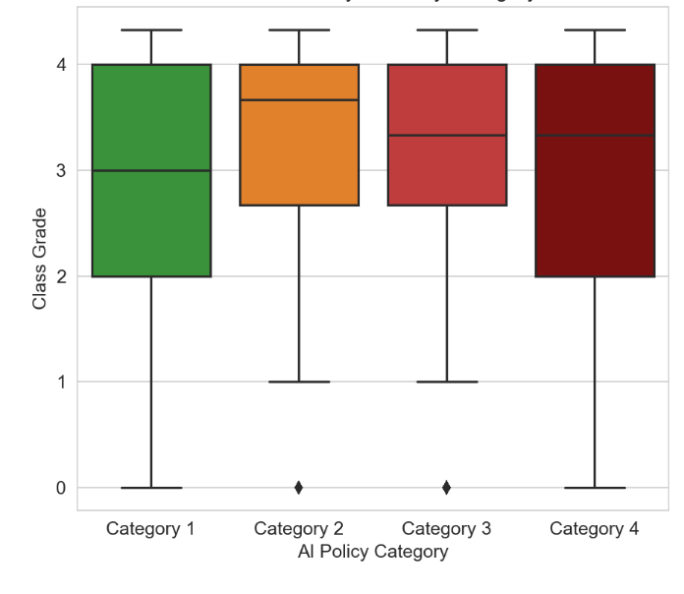
Substantial differences in class grades were found across racial groups. The achievement gap was largest in courses that prohibited all outside resources usage (category 4). International students earned the highest average grades (M = 3.37), followed by Asian students (M = 3.27) and White/Other students (M = 3.09). Hispanic students (M = 2.78) and Black students (M = 2.42) earned the lowest mean grades. These disparities persisted across all policy categories but were largest in courses that prohibited all outside resources and smallest in courses that explicitly prohibited AI (Black: M = 2.68, SD= 1.05; International: M = 3.40, SD= 1.05). First-generation college students earned lower class grades (M = 2.88) than non-first-generation students. This gap was observed across all policy categories, with the largest disparity appearing in courses that prohibited all outside resources. Pell-eligible students earned substantially lower grades (M = 2.81) than non-Pell-eligible students (M = 3.20). The achievement gap between Pell and non-Pell students was present in every policy category and was widest in courses that prohibited all outside resources.
Figure 4
Achievement Heterogeneity: Students Demographics by AI Policies
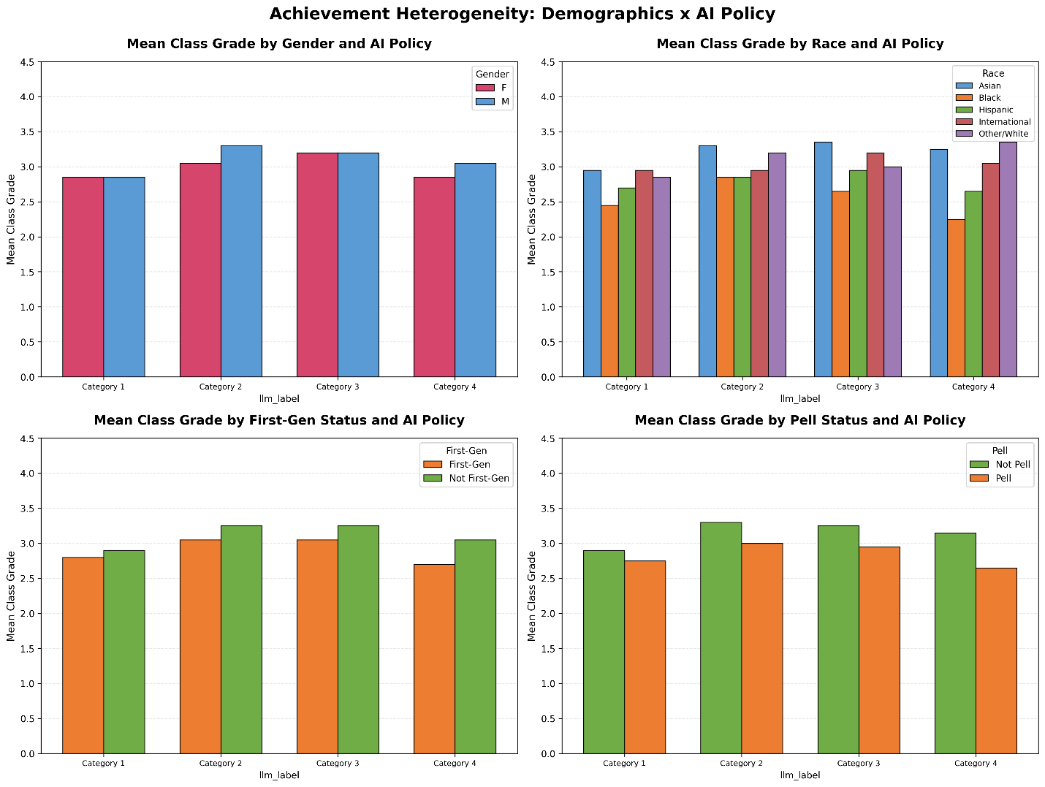AI Course Enrollment. Enrollment across courses also shows variation (Figure 5). The significant chi-square test indicates that student demographic composition is not uniformly distributed across AI policy categories (χ²(12) = 35.92, p < .001, Cramér's V = .056). Asian students exhibited relatively stable enrollment across categories ranging from 16.44% to 21.08%, with the lowest representation in the most restrictive AI usage class. Black students had the least variation across policies (3.42–4.84%) and consistently represented the smallest proportion in all categories. Hispanic students had moderate variation (15.08% – 19.43%), with the highest representation in the most restrictive category (19.43% in "All outside resources prohibited"). White students consistently represented the largest proportion across all categories (30.49%–35.43%). They were most highly represented in the most restrictive category (35.43% in "All outside resources prohibited"). International students showed the greatest variation across categories (18.34%–25.70%, a 7.36 percentage point difference). International students are most highly represented in courses with permissive AI policies (25.70% in "AI allowed with restrictions") and least represented in courses prohibiting all outside resources (18.34%). This could be explained by international students using AI tools to navigate English reading and writing; however we are unable to test this mechanism directly and we acknowledged this as a limitation for future research. Gender composition also differed significantly across policy categories. Male students comprised the majority across all categories but ranged from 74.71% in Category 4 to 82.48% in Category 2. Conversely, female students were most represented in Category 4 (25.23%) and least represented in Category 2 (17.52%).
To examine whether student demographic characteristics systematically predict enrollment in AI-permissive courses, we employed a binary logistic regression model and a multilevel logistic regression model with student demographics at Level 1 and course sections as Level 2 clusters (N = 37,938 students nested within 254 course sections). After accounting for course-section clustering, the multilevel model shows that international student status, Pell eligibility, and Asian student status were no longer statistically significant. The only significant fixed effect was instructor race: courses taught by Asian instructors were associated with substantially higher odds of AI-permissive enrollment (OR = 8.72, 95% CI [2.53, 30.08]). These results suggest that the demographic enrollment patterns observed are largely attributable to course/section-level factors. Unmeasured factors such as scheduling constraints and degree requirements may also contribute to these enrollment patterns; the absence of these variables is acknowledged as a limitation of the current study. Model estimates are in Appendix B.
Instructors. Descriptive analyses and multilevel logistic regression results confirm a consistent trend: Student exposure to AI policies varied substantially by instructor characteristics, indicating that students’ experiences with AI-related course policies depend strongly on who teaches the course. The intraclass correlation coefficient from the multilevel model (ICC = .80) confirmed that approximately 80% of the variance in AI policy exposure was attributable to differences between instructors rather than between course sections.
Figure 5
Enrollment Heterogeneity: Student Demographic Composition by AI Policies
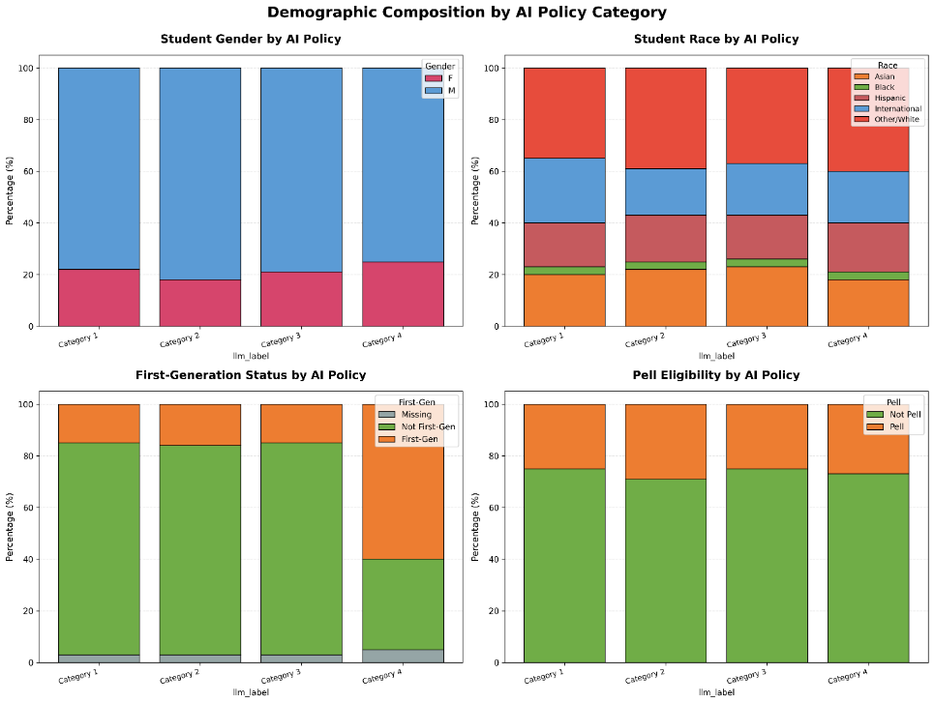
Across instructor characteristics, tenure status showed the most pronounced descriptive differences (Figure 6). Students in courses taught by tenured faculty were more than three times as likely to encounter an AI-specific allowance policy compared to those taught by non-tenured faculty (18.20% vs. 5.17%). Non-tenured faculty were more likely to rely on blanket prohibitions of outside resources rather than addressing AI use explicitly, suggesting that tenured faculty may have greater autonomy or confidence in crafting nuanced AI-specific language. However, in the multilevel regression, tenure status was not a statistically significant predictor of AI policy adoption (OR = 1.34, p = .861).
Gender differences in AI policy exposure were similarly notable in descriptive terms (Figure 6). Male instructors were more likely to include AI-permissive or AI-specific policies, with 9.10% of students in male-taught courses exposed to restricted AI allowance compared to only 1.47% in female-taught courses. Female-taught courses more frequently carried explicit AI prohibitions. Again, however, the regression did not yield a statistically significant gender effect, suggesting that observed descriptive differences may reflect confounding by other instructor characteristics rather than direct gender effects. Lastly, racial and ethnic patterns in AI policy exposure were also evident. Students in courses taught by White instructors and Asian instructors accounted for the largest shares of AI-permissive policy exposure, with White instructors dominating across most policy categories. Asian instructors were notably overrepresented among students in courses that permitted internet resources without explicitly mentioning AI. All model estimates are in Appendix B.

Figure 6
Student-Level Enrollment by Instructor Type (Tenure Vs. Non-Tenure; Male Vs. Female)
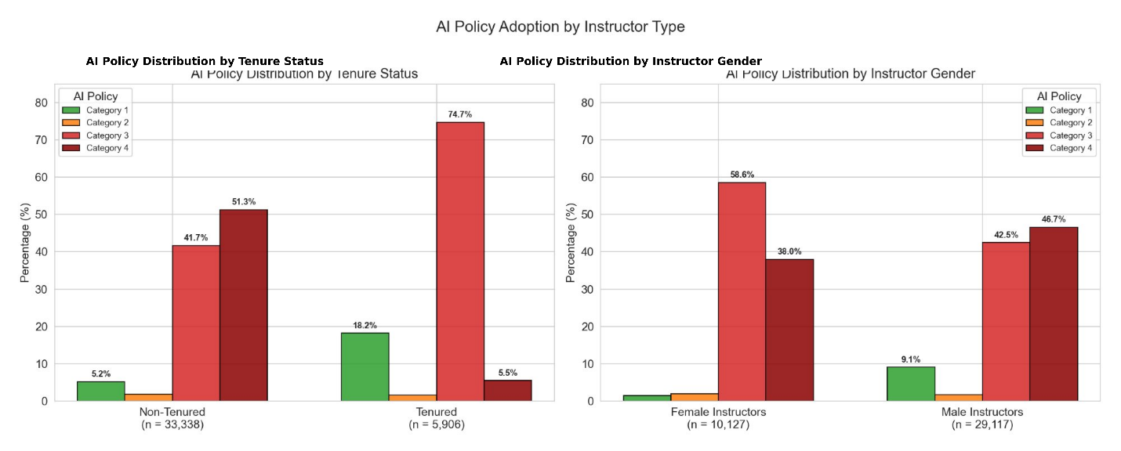 Classes. Our analytic sample included 33 unique undergraduate CSE classes (41,160 student-level observations) spanning across 14 semesters from Spring 2020 to Fall 2024. According to the course syllabi, 10 classes had AI-friendly policies. Student-course enrollments in courses that allowed AI use (N = 2,948) were primarily concentrated in applied computing fields. Majority of these courses were in Information Assurance (71.74%), indicating a concentration of AI permissive policies in cybersecurity-related courses. Additional courses included Intro to Programming Languages (16.66%), Computer Literacy (5.56%), and Intro to Artificial Intelligence (3.53%), which inherently involve computational thinking or computer interaction A smaller proportion of Social Media Mining (2.51%) courses encouraged AI use.
Courses that permitted AI with restrictions (N = 733) were similarly rooted in technical computing domains but exhibited a more moderate adoption profile. The largest share of these courses was in Computer and Network Forensics (43.38%), followed by Computer Graphics (14.73%), Intro to Programming Languages (19.92%), and Intro to Artificial Intelligence (13.23%). A smaller subset of Object-Oriented Programming and Data courses (8.73%) also allowed AI tools under controlled conditions. These findings suggest that AI-friendly courses are most common in cybersecurity and general computing literacy, where AI tools may serve as learning enhancers. A detailed course distribution by policies is in Appendix B.
Regression Results
To examine the association between course-level AI usage policies and student grade outcomes, we estimated a series of mixed-effects regression models with students nested within course sections. Table 2 presents result across four model specifications: a baseline OLS model with clustered standard errors (M1), a hierarchical model (M2), a hierarchical model adding semester fixed effects (M3), and a robustness check restricted to post-ChatGPT semesters (Spring 2023 onward; M4).
AI Policy. Across all model specifications, enrollment in courses that explicitly allowed AI use was associated with significantly lower course grades. In the baseline OLS model (Model 1), students in AI-allowed courses earned grades that were, on average, 0.267 grade points lower than students in AI-prohibited courses (b= -0.267, SE=0.015, p<.001). After accounting for the hierarchical structure of the data (Model 2), the estimated association decreased slightly but remained statistically significant. The magnitude of the association remained substantively unchanged after including semester fixed effects (Model 3; b=-0.228, SE=0.073, p<.001) and when restricting the analysis to post-ChatGPT semesters (Model 4; b=-0.230, SE=0.078, p=.003). These findings indicate that the negative association between AI-permissive course policies and student performance was robust across model specifications.
Student-Level. Among the student-level covariates, cumulative GPA was the strongest predictor of course performance across all models. A one-point increase in cumulative GPA was associated with approximately a 1.14-point increase in course grade (bs = 1.142–1.169). This finding suggests that prior academic achievement remained the primary predictor of student success regardless of course AI policy or model specification. Hispanic, Black, and Pell-eligible students consistently earned significantly lower grades than their respective reference groups across all models. Male students consistently earned higher grades than female students and Asian students generally did not differ significantly from the reference group, although a small positive association emerged in the post-ChatGPT sample. International student status was negatively associated with grades in the baseline OLS model but became statistically nonsignificant after accounting for course-section clustering, suggesting that differences in course enrollment largely explained the initial association.
Instructor-Level. Instructor characteristics were not consistently associated with student course grades after accounting for between-section variation. Neither instructor tenure status nor instructor race was significantly associated with course grades in Models 2 through 4. These findings suggest that observed differences in student performance across instructors were largely explained by section-level heterogeneity captured by the random intercepts rather than by instructor demographic characteristics themselves.
Course- and Semester-Level. Upper-division courses were associated with slightly higher student grades in the baseline OLS model however, this association was no longer statistically significant after accounting for the nested data structure and course-section random effects. This pattern suggests that differences between lower- and upper-division courses were largely attributable to variation across course sections rather than course level alone. The inclusion of semester fixed effects produced minimal changes in the estimated coefficient for AI policy, indicating that the association between AI-permissive policies and lower course grades was not driven by differences across semesters. Additionally, the estimated variance of the section-level random intercept remained relatively stable across mixed-effects models, indicating persistent between-section variation in average course grades even after controlling for observed student, instructor, and course characteristics.
Table 2
Mixed-Effects Regression Models Predicting Student Course Grade by AI Policy Across Model Specifications
 | M1: Base OLS | M2: Hierarchical | M3: + Semester FE | M4: Post-ChatGPT
AI policy (1 = allowed) | −0.267*** (0.015) | −0.237*** (0.073) | −0.228*** (0.073) | −0.230** (0.078)
Cumulative GPA | 1.169*** (0.006) | 1.149*** (0.005) | 1.149*** (0.005) | 1.142*** (0.006)
Upper division | 0.093*** (0.010) | 0.053 (0.058) | 0.079 (0.060) | 0.057 (0.066)
Student Demographics
Asian | 0.005 (0.011) | 0.020 (0.011) | 0.020 (0.011) | 0.026* (0.012)
Hispanic | −0.054*** (0.012) | −0.051*** (0.011) | −0.051*** (0.011) | −0.045*** (0.012)
Black | −0.094*** (0.021) | −0.107*** (0.020) | −0.107*** (0.020) | −0.111*** (0.021)
International | −0.046*** (0.011) | −0.003 (0.011) | −0.003 (0.011) | −0.004 (0.012)
Male | 0.092*** (0.010) | 0.127*** (0.009) | 0.126*** (0.009) | 0.123*** (0.010)
Pell eligible | −0.059*** (0.010) | −0.064*** (0.009) | −0.064*** (0.009) | −0.067*** (0.010)
Instructor Characteristics
Instructor: Asian | −0.155*** (0.012) | −0.054 (0.055) | −0.061 (0.056) | −0.046 (0.061)
Instructor: Hispanic | 0.070* (0.028) | 0.102 (0.139) | −0.055 (0.149) | −0.055 (0.143)
Instructor: Multiracial | 0.027 (0.026) | −0.025 (0.112) | −0.045 (0.116) | −0.048 (0.120)
Tenured | −0.052*** (0.013) | 0.002 (0.064) | 0.002 (0.065) | 0.056 (0.072)
Semester fixed effects | No | No | Yes | Yes
Course fixed effects | No | No | No | No
Section random effects | No | Yes | Yes | Yes
Sample | Full | Full | Full | Post-2023
Var(section RE) | — | 0.106 | 0.104 | 0.112
Var(residual) | — | 0.542 | 0.542 | 0.555
Note. M1 = baseline OLS with clustered standard errors by section. M2 = mixed-effects model with section-level random effects and no fixed effects. M3 = mixed-effects model with section random effects and semester fixed effects (reference: semester 2227). M4 = M3 restricted to post-ChatGPT semesters (Spring 2023 onward). Coefficients are unstandardized. Standard errors in parentheses. Dependent variable is classgrade. * p < .05. ** p < .01. *** p < .001.

Robustness
As a sensitivity analysis addressing potential selection bias from excluding courses with no stated AI policy, we re-estimated the model on the full sample of 112,014 student-course observations, treating courses with no stated policy as a distinct reference category. AI-permissive courses were associated with significantly lower grades relative to no-policy courses (b = −0.280, SE = 0.089, p = .002), a result consistent with the primary analysis. This sensitivity model partially addresses concerns about selection bias by demonstrating that the negative association is not an artifact of restricting the analytic sample to policy-stating courses. However, it does not eliminate the possibility of unobserved selection; for instance, instructors who adopt AI-permissive policies may systematically differ from those who do not in ways unmeasured in the present data (e.g., pedagogy, grading standards, or course rigor). The consistency of estimates across both specifications increases confidence in the robustness of the association, though the relationship remains correlational and should not be interpreted causally. All model estimates can be found in Appendix C.
In addition, we conducted an analysis using a stricter definition of "AI-permissive" that excluded category 2 (syllabi permitting internet resources without explicitly addressing AI). This narrower operationalization isolates courses where instructors made a deliberate, unambiguous decision to permit AI use, reducing the possibility that the primary estimate was inflated by courses whose permissiveness toward AI was incidental rather than intentional. Under this stricter definition, the negative association between AI-permissive policy and course grades was larger in magnitude and more precisely estimated (b = −0.323, SE = 0.079, p < .001). The fact that the estimate strengthens rather than attenuates under the more conservative definition reassures the primary finding was not driven by misclassified or ambiguously coded courses. All model details are reported in Appendix C.
Heterogeneity
To examine whether the relationship between AI-permissive policies and academic performance differs across student demographic groups, cumulative GPA and course level, we estimated a series of interaction models. Each model includes a single interaction between AI usage and a demographic indicator, with random intercepts for classes to account for clustering. A significant negative interaction was observed between AI policy and course level ($b$ = −0.417, SE = 0.157), indicating that the association between AI-permissive policies and course grades differed by course level (Figure 7). Among lower-division students, AI permissive policies were significantly associated with higher course grades, while among upper-division students, AI-permissive policies were associated with substantially lower grades. This finding may also help explain the insignificant coefficient of upper division found in the previous analysis. As shown in the margin plot positive lower-division effect and negative upper-division effect cancel out in the average.
Figure 7
AI Policy * Course Level Model Coefficient Plot
A significant positive interaction emerged between AI-permissive policy and centered cumulative GPA (b = 0.259, SE = 0.022, p < .001), indicating that the association between AI-permissive policy and course grades was moderated by students' prior academic ability. At the sample mean GPA, AI-permissive policy was associated with lower course grades (b = −0.237, SE = 0.074, p < .001). The strength of this negative association varied systematically across the ability distribution: simple-slope estimates indicated a penalty of approximately −0.59 grade points for students one to two standard deviations below the mean (around GPA 2.0), narrowing to approximately −0.33 at GPA 3.0 and to approximately −0.07 at GPA 4.0. The negative association was thus concentrated among, and largest for, students with below-average prior GPA, and attenuated toward zero as prior achievement increased.
This pattern is consistent with theoretical accounts of intelligence amplification, under which students with stronger prior knowledge may be better positioned to deploy generative AI as a complement to their own reasoning rather than as a substitute for it. We emphasize, however, that these accounts are offered as plausible interpretations rather than as mechanisms tested by the present design: because we did not observe students' actual AI usage, we cannot determine whether the moderating role of prior GPA operates through differences in how students use AI, through unobserved characteristics correlated with both GPA and grades, or through other pathways. The estimates reported here are associational rather than causal. Future research incorporating direct measures of AI usage frequency, purpose, and the specific tasks for which students rely on generative tools would help adjudicate among these explanations and clarify the conditions under which AI-permissive policies help or harm students of differing ability. Estimates of AI usage and interaction between cumulative GPA and course level can be found in Table 3.
Figure 8
AI Policy * Cumulative GPA Model Coefficient Plot
Across all twelve models, the main coefficient remains negative and statistically significant (ranging from −0.23 to −0.29), confirming the core finding holds regardless of which demographic interaction is included. However, none of the AI × demographic interaction terms are statistically significant, providing no evidence that the relationship differs by the demographic groups. The interaction between AI and international student status is negative but not statistically significant, suggesting that the modest negative association between AI and grades does not differ reliably between international and domestic students. Similarly, the interaction between AI and Asian student status is positive but nonsignificant, indicating no detectable difference for Asian versus White students. AI usage policy was associated with lower grades for students in general; we found no statistically significant evidence that this association varied by international status, race, or ethnicity. A full model estimate can be found in Appendix D.
Table 3
Heterogeneity Interaction by Course Level, and Cumulative GPA
 | Variable | AI × Upper Division |  | AI × Cumulative GPA
 | AI policy (1 = allowed) | 0.044  (0.125) | −0.237***  (0.074)
AI × Upper division |  | −0.417**  (0.157) | —
AI × Cumulative GPA (centered) |  | — | 0.259***  (0.022)
Cumulative GPA |  | 1.149***  (0.005) | —
 | Cumulative GPA (centered) | — | 1.134***  (0.005)
 | Upper division | 0.124*  (0.062) | 0.079  (0.060)
 | Asian | 0.020†  (0.011) | 0.019†  (0.011)
 | Hispanic | −0.051***  (0.011) | −0.052***  (0.011)
 | Black | −0.107***  (0.020) | −0.108***  (0.020)
 | International | -0.003  (0.011) | -0.005  (0.011)
 | Male | 0.126***  (0.009) | 0.127***  (0.009)
 | Pell eligible | −0.064***  (0.009) | −0.063***  (0.009)
 | Instructor: Asian | −0.030  (0.056) | −0.066  (0.056)
 | Instructor: Hispanic | −0.052  (0.147) | −0.062  (0.150)
 | Instructor: Multiracial | −0.032  (0.114) | −0.048  (0.116)
 | Tenured | 0.000  (0.064) | 0. 000  (0.065)

Our dataset does not include individual-level measures of English language proficiency, and we do not treat nationality-based international student status as an adequate proxy for language ability. We acknowledge this as a limitation of the present study and encourage future research to incorporate language proficiency measures

